ELEMENTARY SCHOOL MEALS PROGRAM
LUNCH ORDER FORM

School’s Name: Westwood Elementary
Student’s Name:
Grade:
Division:
Teacher:

Allergies / Religious Requests: _____________________________________

Payment Amount: _______________



APRIL 2015

MONDAY | TUESDAY | WEDNESDAY | THURSDAY | FRIDAY
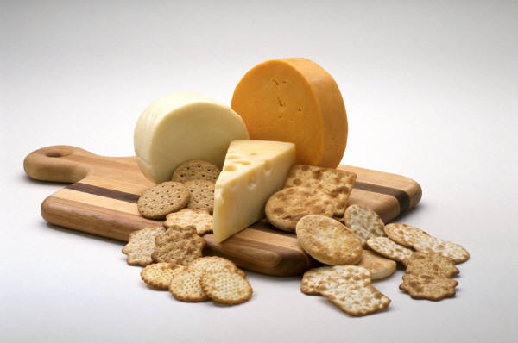 | 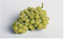 | 1  White Milk  Caesar Salad  Granola Bar  Fruit | 2  Fruit Juice  Tuna Sandwich  Veggies & Dip  Yogurt | 3  GOOD FRIDAY
6  EASTER MONDAY | 7  Chocolate Milk  Cheese Sandwich  Chips  Fruit | 8  Fruit Juice  Chef Salad  Bread Sticks  Fruit | 9  White Milk  Ham Sandwich  Pudding  Veggies & Dip | 10  Fruit Juice  Egg Sandwich  Granola Bar  Yogurt
13  Chocolate Milk  Salami Sandwich  Cookie  Fruit | 14  Fruit Juice  Turkey Sandwich  Pudding  Veggies & Dip | 15  White Milk  Cheese/Jam Mini Croissant  Rice Krispie Square  Fruit | 16  Fruit Juice  Salsa/Chips  Granola Bar  Yogurt | 17  DISTRICT  NON-INSTRUCTIONAL DAY
20  Chocolate Milk  Cheese Sandwich  Cookie  Fruit | 21  Fruit Juice  Roast Beef Sandwich  Yogurt  Veggies & Dip | 22  White Milk  Caesar Salad  Pretzel  Fruit | 23  Fruit Juice  Egg Sandwich  Cookie  Yogurt | 24  Chocolate Milk  Cream Cheese/Jam Bagel  Veggies & Dip  Fruit Cup
27  Fruit Juice  Cheese Sandwich  Yogurt  Trail Mix | 28  White Milk  Ham Sandwich  Cookie  Fruit | 29  Fruit Juice  Chef Salad  Bread Sticks  Pudding  Fruit | 30  Chocolate Milk  Tuna Sandwich  Granola Bar  Fruit | 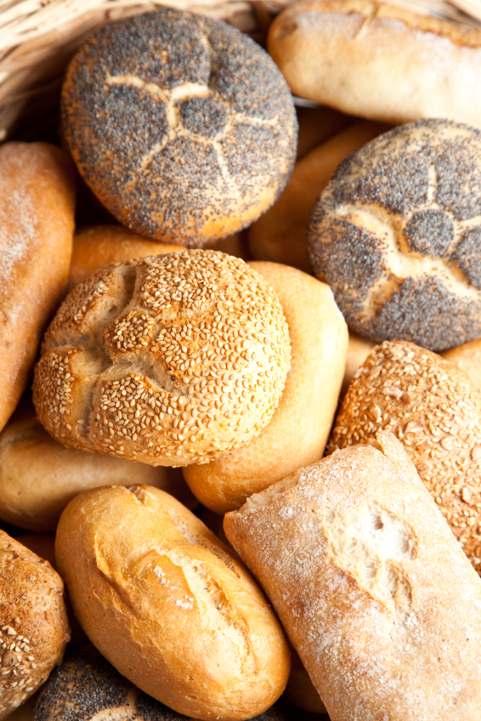

PLEASE NOTE:

- WE DO NOT GUARANTEE A NUT-FREE ENVIRONMENT. ALL OF OUR BREADS AND BAKED GOODS MAY CONTAIN TRACES OF NUTS.

- MENU SUBJECT TO CHANGE BASED ON AVAILABILITY FROM SUPPLIERS.

- April Lunches: 19 @ $4.00 = $76.00
- Please make cheque payable to the school.

- ORDERS DUE TO OFFICE BY 9:00 AM, TUESDAY, MARCH 24, 2015. SORRY, LATE ORDERS WILL NOT BE ACCEPTED.

